### FTP Adapter in OIC

<https://www.youtube.com/playlist?list=PLlzOCTRJKR1K5r8YS6mgsllTOZijDulRl>

* FTP Adapter is used to retrieve the files for processing in Oracle Cloud and can upload files from OIC to a Directory on a remote FTP Server.
* Uses PGP(Pretty Good Privacy) cryptography to encrypt and decrypt.
* Supports signing and un-signing of files.
* Can connect to FTP, SFTP servers, which are accessible over the internet.
* Enables to create schema file format(created from either a CSV file or an existing schema file) to use the files to transfer.
* Delimiters 🡪 single spaces, commas, semi columns, or tabs.
* Operations Supported :

1. List File
2. Read File
3. Write File
4. Download File
5. Move File
6. Delete File

All the above listed operations are synchronous and provide Responses, and support dynamically passing the headers(directory, file name, etc.….).

* Host key Authentication, Public key Authentication and streaming support for large files.

**Use-cases 1**: To **Write** a file to FTP Server.

1. First create a Connection using FTP Adapter.
2. In integration page click on create and choose App Driven Orchestration. Then give the name and click on create.
3. In the integration add a rest connection to invoke this API
   1. In the properties give the name to this element as create_File, give the URI as \createFile, select POST method.
   2. Check the options as *configure the request payload* and *configure this end point to receive response*. Click on next.
   3. Give the request payload as json in inline click next.
   4. Give the response payload by selecting JSON option and click on next and done.
4. Add the FTP connection and configure the properties.
   1. Give the name to the element as writeFile.
   2. In operations select **write** operation, select transfer mode(I have selected binary), give the output directory location and specify the file name pattern(Sample_%SEQ%.csv), click on next.
   3. Select the respective schema and click on next.
   4. In definition upload a sample file to create xslt and fill the options with appropriate values and click on next and done.
5. While mapping for write file mapper on the response side create a repeat node so that we can handle multiple data and map the created repeated node elements with the source elements, and for the before node in the target initialize with Header hard coded values.
6. Add a new mapper and map the status elements on both sides, click on validate.
7. Always click on save while adding a new element as a best practice.

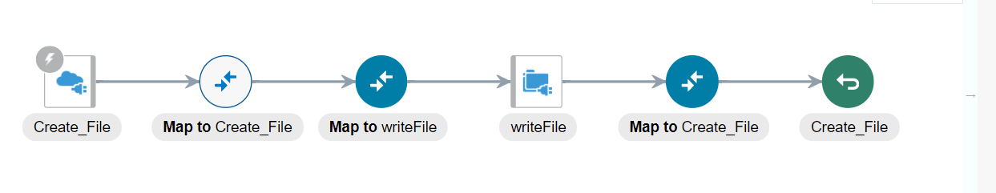

**Use-case 2**: To **Read** a file from FTP server and send the information in that file as a Response.

1. First create an FTP Connection.
2. Create an Integration and add a Rest connection to invoke this integration, in the properties give the name, URI, and select the operation as GET(since we need information from FTP Server).
   * 1. Select add review parameter for this end point and configure this end point to receive response.
     2. Add request parameter as file name with data type as string.
     3. Configure the response by adding an inline JSON code, click on done.
3. Add FTP Adapter.
   * 1. In basic info give name as Read File.
     2. In Operations, select operation as 🡪Read File, Transfer Mode 🡪 Binary, input Directory 🡪 location of FTP server where the file to be read exists, File Name 🡪 Sample file Name(we will pass the file name as req parameter).
     3. Schema 🡪 Upload a sample CSV file as of file to be read.
     4. Definition 🡪 select delimited data file, record, record-set name 🡪 Done.

In Read File Mapper map the file name from src to target and in the File Based Operation mapping do the necessary mappings.

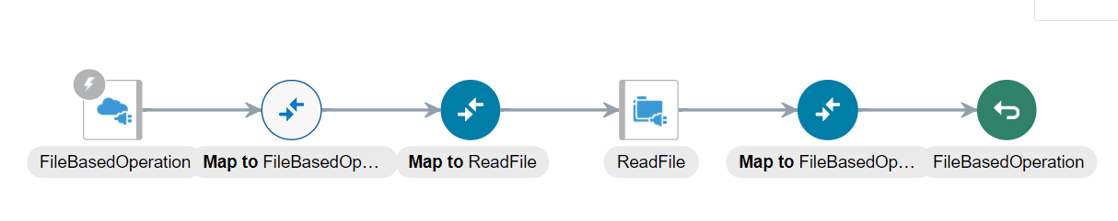

**Use-case 3**: To **move** files from one directory to another directory using FTP Adapter.

1. Create a schedule integration 🡪 MoveFiles
2. List files from source directory using FTP Adapter.
   1. Insert an FTP Adapter, in operation select LIST FILES, give directory path.
   2. File Name Pattern 🡪 Give as *(All the files in the directory will listed)
3. Loop over files using FOR Loop.
   1. Give the repeating Element as *ListFiles🡪ListFileResponse🡪ListResponse🡪File List🡪File*
4. Move file to target directory using FTP Adapter.
   1. In the loop created above insert an FTP Adapter, and give the operation as Move a File.
   2. Give the source directory Path and Target directory path. Done,
   3. In the mapping in loop, map the file name from source to both file name and target file name in target, and map the directory on both sides.

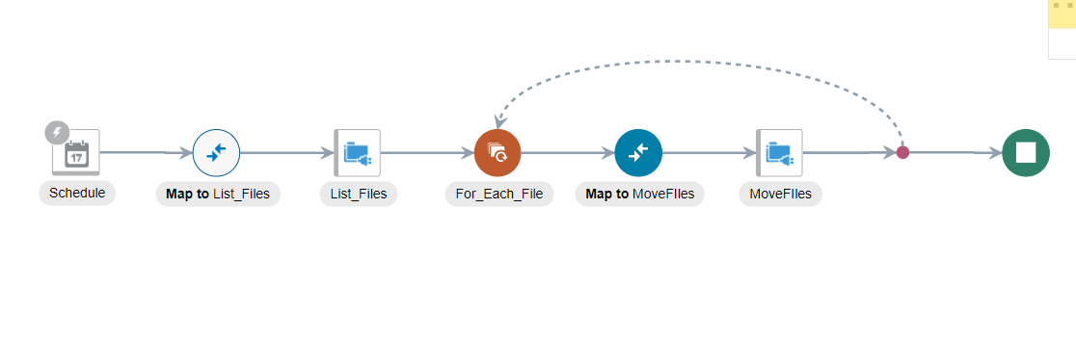

**Use-case 4**: To transfer files from one SFTP to another SFTP using FTP Adapter.

1. Create a schedule integration.
   1. In the integration page click on create, select scheduled orchestration an configure it’s properties.
2. List files from source SFTP using FTP Adapter.
   1. Select source FTP connection
   2. Select LIST FILES operation
   3. Give the input directory location.
   4. File Name Pattern as * (to select all the files).
   5. Max Files 🡪 maximum files to list, give as 100
   6. Minimum Age 🡪 last modified date, give as 0.
   7. List Files Recursively 🡪 if check then list the files from sub directory as well.
3. Loop over the files using FOR EACH LOOP.
   1. To read files one-by-one drop a for each loop and give the File under List Response/File List as repeating element.
4. Read file one-by-one using Read Operation.
   1. Add a source FTP connection in the loop to read each file.
   2. Select the operation as READ FILE and give input directory path.
   3. In schema select NO, since we want exact file structure as in source file.
   4. Map directory to directory and file name to file name.
5. Write the file to target SFTP using write operation.
   1. Select Target FTP Connection in the loop after read file.
   2. Select the operation as Write File.
   3. Transfer mode 🡪 ASCII
   4. Give the Output Directory
   5. File name pattern as “*”
   6. Schema 🡪 No
   7. Map Read File Response/ICS File/File Reference to *ICS File/File Reference.*
   8. File Response/File Name to Out bound FTP header/File Name.

**Use-case 5**: Processing Large files using FTP adapter in OIC.

* “Read File” operation in FTP has a limitation that it can handle only data < 10 MB.
* “Download File” operation allows to stage a file up to 1GB.
* “Stage” activity allows us to read file in chunks, and in each chunk, it can read up to 200 records.